Lanford Gabriel Murillo

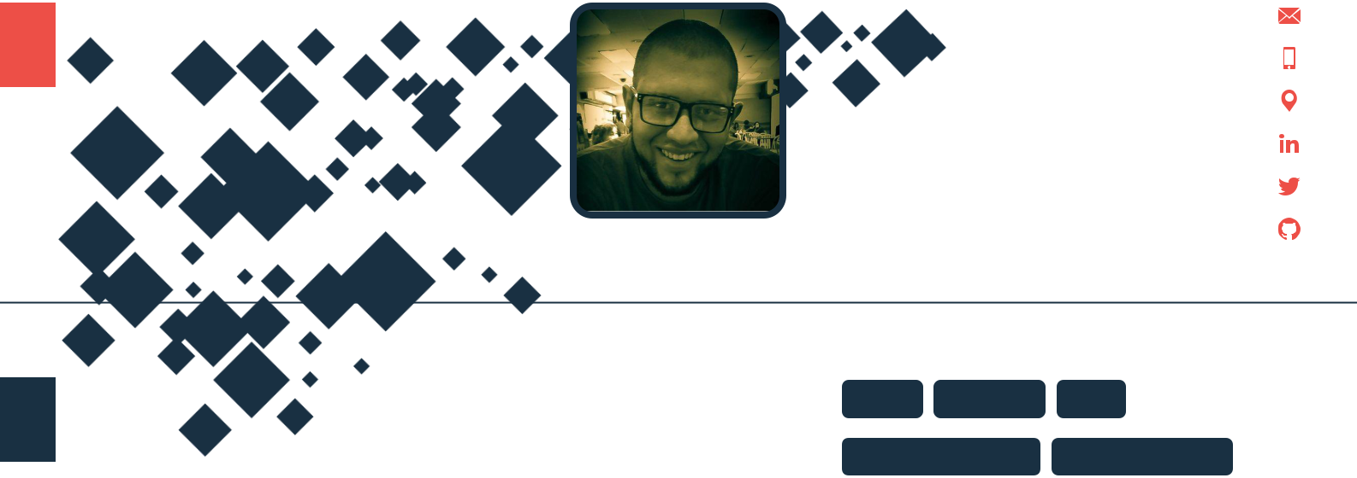

Software Support Especialist/Developer

Passionate about life and technology, always striving to give the best of myself at any time and place.

[holtlanf999@gmail.com](mailto:holtlanf999@gmail.com)

83168552

Heredia, Costa Rica

[linkedin.com/in/lanford-gabriel-murillo](https://www.linkedin.com/in/lanford-gabriel-murillo)

[twitter.com/holtlanf999](https://twitter.com/holtlanf999)

[github.com/holtlanf999](https://github.com/holtlanf999)

**WORKING EXPERIENCE**

**Software Support Especialist Level III** Micro Focus (Formerly HPE Software)

*11/2016 – 11/2018* *Heredia, Costa Rica*

*Micro Focus International plc is a multinational software and information technology business.*

*Achievements/Tasks*

**SKILLS**

Linux Windows SQL

Customer Support Troubleshooting



Log Analysis Team Work SOAP

Level III Software Specialist in charge of delivering high end customer support through emails, calls or remote sessions, always in line with the company guidelines and metrics.



Customer satisfaction top 3 for 9 months in a row.



Coordination of training and creation of knowledge documents used to help solve further cases.



*Contact: Jared Kennedy –*

*Phone: +732 610 9121 Email: jared.kennedy925@gmail.com*

**Full Stack Web Developer**



Mobile33

*02/2016 – 10/2016* *San José, Costa Rica*

*SMS suscription content delivery company located in Costa Rica*

*Achievements/Tasks*

Creation of landing pages, interactive portals, content delivery web pages and web service endpoints.



REST LDAP Active Directory



JAVA Python JavaScript PHP



CSS HTML AngularJS NodeJS



MongoDB Docker XML JSON



Training

**LANGUAGES**

Spanish (Native)



Optimization of nearly a 40% on the page loading speeds by changing the php logic, javascript files loading methods and CSS stylesheets minification which translates in a better user experience.



Increase of productivity and compatibility of the whole web platform with new technologies by changing the web service interface from old SOAP web services to new REST API's.



*Contact: Fernando Rodriguez –*

*Phone: +506 8810 2299 Email: fernando.crodriguez@gmail.com*

English (Fluent)



**INTERESTS**



Technology Programming



PC Hardware Music Data Science

**Team Leader**



Ingram Micro Mobility (Former BrightPoint)

*01/2013 – 03/2014* *Lindora, Costa Rica*

*Ingram Micro is an American distributor of information technology products. The company ranked 64th in the 2016 Fortune 500.*

*Achievements/Tasks*

Monitoring team production numbers, quality control, ensuring compliance with quality standards and 5's.



Improvement of the production numbers by implementing faster assembly and disassembly processes through custom made training guides.



Implementation of a quality assurance process which decrease by 30% the number of parts that were sent to materials area in bad shape.



Programming trends Cars Gaming



AI



*Page 1 of 2*

**EDUCATION**



**Computer Science Bachelor's Degree** Universidad Fidélitas



*2017 – Present* *Heredia, Costa Rica*

*Courses*

Technical Fundamentals.  Programming Introduction.

Networking.  Software Documentation.

Databases.  Programming Paradigms.

Operative Systems.  Data Structures.

System Analysis.  System Audits.

**Web Design and Development Technician**



CETAV (Centro de Tecnología y Artes Visuales)

*2014 – 2015* *San José, Costa Rica*

*Courses*

Programming Fundamentals.  HTML.



CSS.  JavaScript.



Data Bases.  User Experience (UX).



Web Design layouts.  Color Theory.



Conversational English.  Entrepreneurship.



**Electronics Technician with Telecom Emphasys**



Colegio Técnico Profesional de San Sebastian

*2010 – 2012* *San José, Costa Rica*

*Courses*

Analog Electronics  Digital Electronics



Fundamentals. Fundamentals.

Advanced Analog Electronics.  Advanced Digital Electronics.



Telecoms.  Networking.



Electricity.  Electronics fundamentals.



PLC's and Microcontrolers.  Computer Support Basics.



*Page 2 of 2*